1. *Find the Marginal Distribution p(x)*

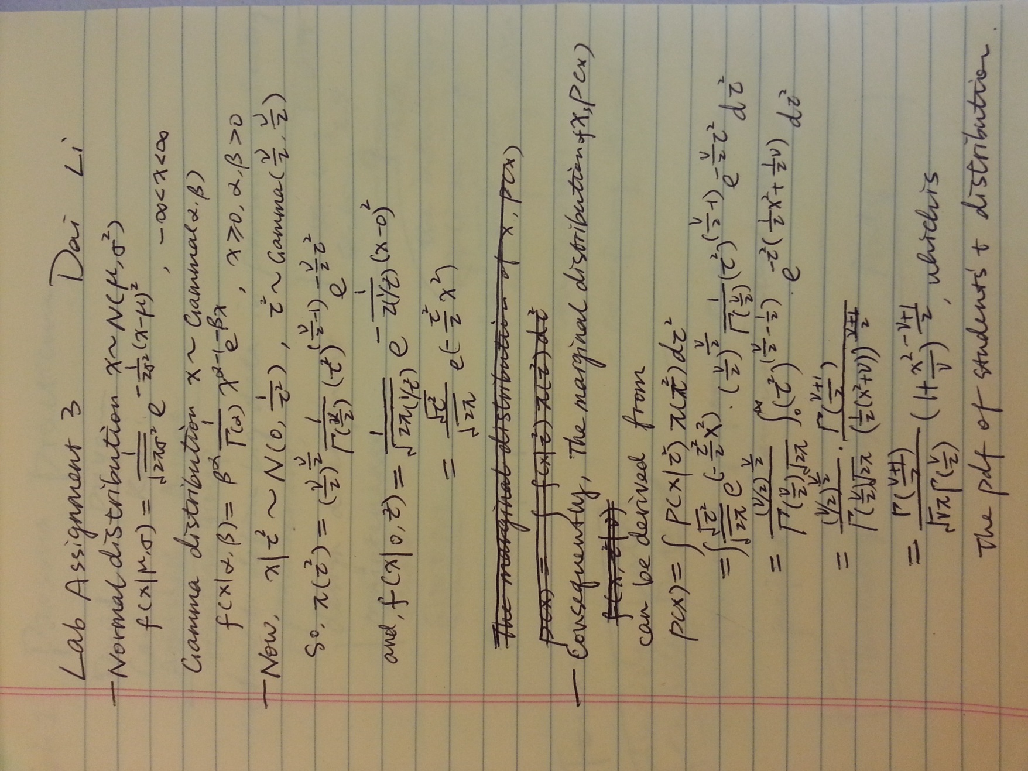

2. *Let nu=1. Get a sample of 10,000 from marginal distr. of x by drawing 10,000 tau^2's and then 10,000 x's given the tau^2's. Plot sample (either histogram or density is fine). Give two names for the actual marginal distribution p(x) when nu=1. Also, compute 2.5% & 97.5% percentile points of the distribution using the random samples and compare them to the theoretical values.*

The actual marginal distribution p(x) when nu=1 is plotted below:



Which is a **Students’ T Distribution with parameter Nu=1**. As, Nu=1, it is also a Cauchy Distribution with location parameter=0 and a scale parameter.

While using the 10000 sample points, we can draw out the theoretical conditional density of p(x|tau.square), which is plotted below:



Which is a Student’s T distribution truncated to [min(x.tau.square.sample), max(x.tau.square.sample)], whose p(x)sample value histogram is also plotted below:



The 2.5% & 97.5% percentile points of theoretical p(x) are ***(-12.7062, 12.7062).*** While, the 2.5% & 97.5% percentile points of sampled p(x) are ***(0.009560445, 0.3877215).***

3*. Use Kolmogorov-Smirnov test (ks.test in R) to test whether your observed distribution is equal to a t(df=1). Report p-value. What is the conclusion of the test?*

Under null-hypothesis, p-value < 2.2e-16,

Using the sample points, D= 0.5853.

Conclusion of the test: R eject the hypothesis-***the observed distribution is not equal to a t(df=1).***

4. *Does the Central Limit Theorem hold for the mean of a sample from p(x) when nu=1? What about nu=2? nu=3? Why or why not? A quick explanation will do; an involved proof is NOT required.*

Given nu=1,2,or 3, there are finite value of X, so that there are finite value of mean E(x) and variance Var(x), and thus, the Central Limit Theorem hold for the sampled p(x).